How to Apply to Norco College Summer Advantage Program. INSTRUCTIONS
Go to www.norcocollege.edu/summeradvantage
Scroll down to Steps to Participate, and select Step 1

When applying to Norco College Summer Advantage program, use must fill out your information on cccapply, then the Norco College application will appear. Select start application. Get started
Important points on the application IMPORTANT INFORMATION YOU MUST FILL OUT
- Term – Select FALL 2018 (DO NOT SELECT SUMMER 2018)
- Graduation Date - May 31, 2018
- Graduate from high school with Diploma
- SUPPLEMENTAL APPLICATION – You need to select YES for the Summer Advantage Program
- CONFIRMATION PAGE -Take a picture or printout to show Mrs. Matthews in the Career Center.

In 48 hours allow 2 workdays, you will receive your Norco College ID number and WebAdvisor User ID. Please keep this information, you will need it to complete steps 2, 3, 4 and 5

Now go login to www.norcocollege.edu/summeradvantage website and go to Step 2 (click on)

You will now see this WebAdvisor page. Go to Log in.

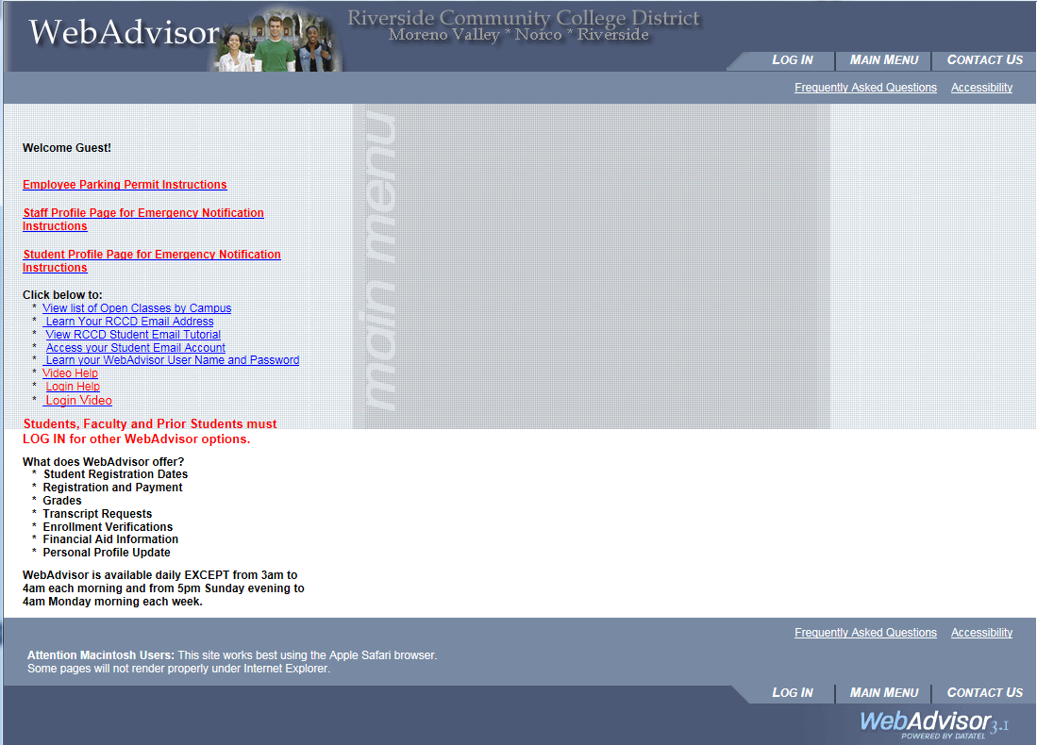

Look at your email that Norco College sent to you that has your Norco College ID # and your WebAdvisor User ID.

Step 1 – type your Norco College ID# in the User ID area. It will have a series of 7 numbers which is your Norco College ID. (Example – 2234567). Your password will be your birthdate. Example if your birthdate is April 9, 2000 type it in like this 040900.
User ID will be your Norco College ID# Your Password (birthdate)
The next page will tell you that your password has expired.
- This is where you need to put in your Norco College ID# .
- Put in your password which is your birthdate (040900) do not put 2000 4 digit year just last 2 digits of your birth year.
- Enter a new password (it has to be between 6 – 9 characters and must contain 1 letter and 1 number) SUGGESTION: Use your first and last name initials and your Norco ID #
- Jm2234567. This way you will remember your Norco College ID# and you already know your initials and it contains 9 characters which contain letters and numbers.
- Confirm your new password
- Submit

This should open up your WebAdvisor and should say Hi (Your Name)! In the left corner. Look to the right and you will see a blue box that says STUDENTS.

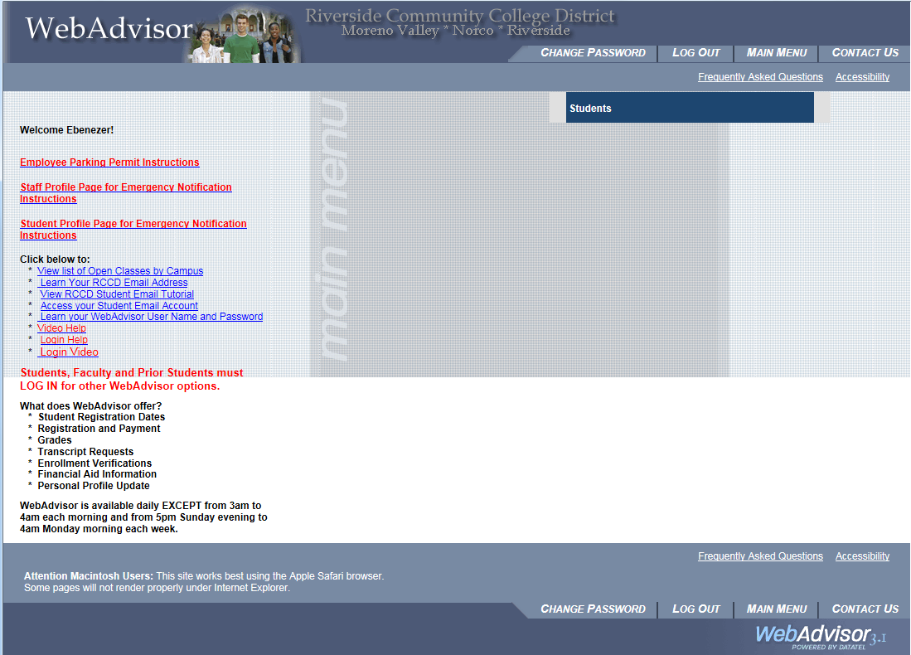

Click on the Students box. Now you will see a large menu of services available for you.
Go to the right side of the page near the bottom. And look for TAKE ONLINE ORIENTATION. SELECT AND NOW YOU WILL BE READY TO START STEP 3.

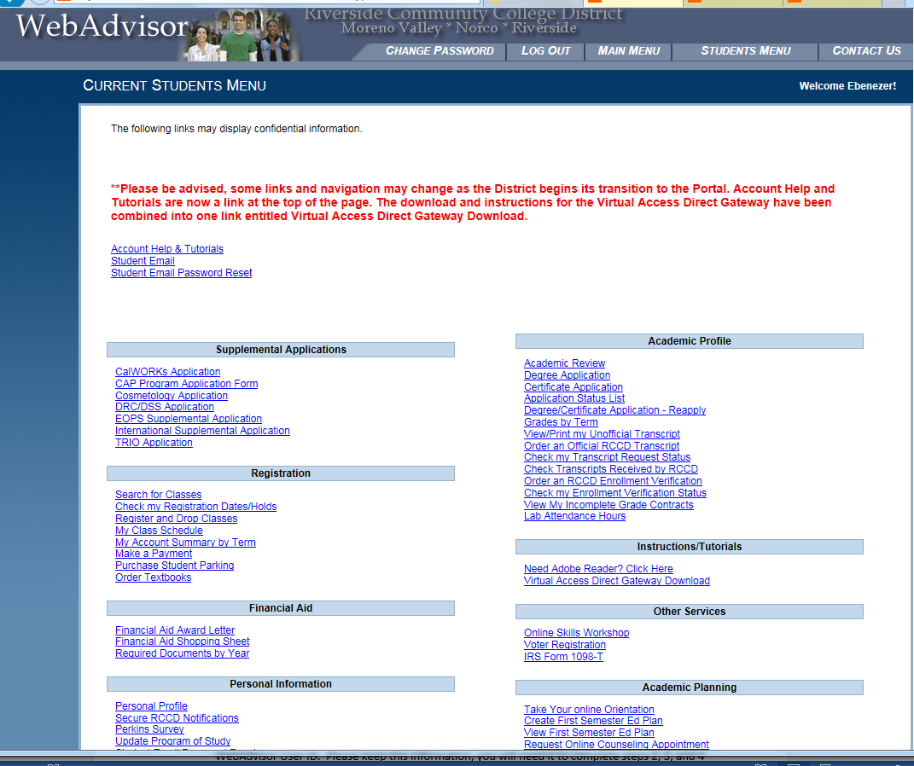

The ONLINE ORIENTATION VIDEO CAN TAKE UP TO 40 MINUTES. YOU CAN DO THIS AT HOME AS LONG YOU HAVE INTERNET ACCESS AND CAN LOG IN TO YOUR WEBADVISOR.

WHEN YOU GET NEAR THE END OF THE FINAL STEPS OF ORIENTATION, TAKE A PICTURE OF THE LAST PAGE OR PRINT IT OUT BY RIGHT CLICKING ON YOUR MOUSE AND PRINT. BRING THIS CONFIRMATION TO MRS. MATTHEWS IN THE CAREER CENTER – ROOM 303.

NOW YOU CAN TAKE YOUR ASSESSMENT TEST AFTER YOUR ORIENTATION HAS BEEN VERIFIED BY NORCO COLLEGE ASSESSMENT COORDINATOR. Go to www.norcocollege.edu and go to Assessment Link

After you take your Assessment Test, you are now ready to CREATE FIRST SEMESTER ED PLAN. Sign in to www.norcocollege.edu website and select WEBADVISOR then sign in and go to Academic Planning Section and select CREATE FIRST SEMESTER ED PLAN. Select course and term you plan on taking the course (Example: FALL 2018). Take a picture or print out a copy for your records and submit. Then view FIRST SEMESTER ED PLAN.

YOU MUST CHECK YOU NORCO COLLEGE EMAIL FOR ANY MESSAGES FOR SUMMER ADVANTAGE OR ANY INFORMATION SENT FROM NORCO COLLEGE. IT IS YOUR RESPONSIBILITY TO CONTINUE TO CHECK YOUR EMAIL.

